Data Acquisition System

Interfacing the 8051 Microcontroller with Digital Sensor, Analog Sensor, 16x2 LCD and more

Chiș George 2032
Îndrumător: Prof.dr.ing. Toma Mihai Pătărău

SECTION 1.0: OVERVIEW OF THE PROJECT

The aim of this project is to successfully design a fully automated Data Acquisition System which will monitor the environmental humidity and temperature, display it in a human-readable interface and allowing the user to control some of these environmental conditions.

For this goal, an automated microcontroller-based system will be implemented, by interfacing a Microcontroller from the 8051 Family with a Digital Sensor (for the humidity) and an Analog Sensor (temperature), a 16x2 LCD and some LEDs and Push-buttons.

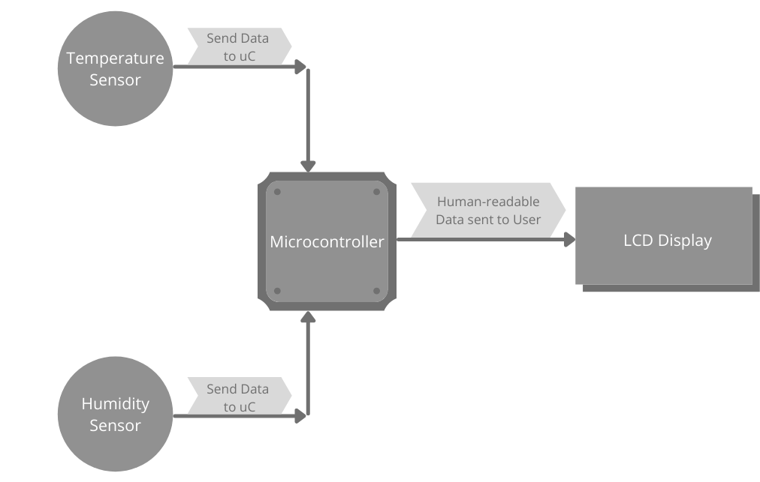
Figure 1.0.0: Flow Chart of the Data Acquisition System

SECTION 1.1: OVERVIEW OF THE 8051 FAMILY

In this section we first look at the various members of the 8051 family of microcontrollers and their internal features. Plus we see who are the different manufacturers of the 8051 and what kind of products they offer.

A brief history of the 8051
In 1981, Intel Corporation introduced an 8-bit microcontroller called the 8051. This microcontroller had 128 bytes of RAM, 4K bytes of on-chip ROM, two timers, one serial port, and four ports (each 8-bits wide) all on a single chip. At the time it was also referred to as a “system on a chip.” The 8051 is an 8-bit processor, meaning that the CPU can work on only 8 bits of data at a time. Data larger than 8 bits has to be broken into 8-bit pieces to be processed by the CPU. The 8051 has a total of four I/O ports, each 8 bits wide. See Figure 1-2. Although the 8051 can have a maximum of 64K bytes of on-chip ROM, many manufacturers have put only 4K bytes on the chip. This will be discussed in more detail later.

Table 1.1.0: Features of the 8051
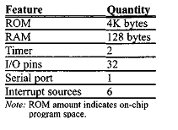

The 8051 became widely popular after Intel allowed other manufacturers to make and market any flavors of the 8051 they please with the condition that they remain code-compatible with the 8051. This has led to many versions of the 8051 with different speeds and amounts of on-chip ROM marketed by more than half a dozen manufacturers. Next we will review some of them. It is important to note that although there are different flavors of the 8051 in terms of speed and amount of on-chip ROM, they are all compatible with the original 8051 as far as the instructions are concerned. This means that if you write your program for one, it will run on any of them regardless of the manufacturer.

8051 microcontroller
The 8051 is the original member of the 8051 family. Intel refers to it as MCS-51. Table 1-3 shows the main features of the 8051.

Figure 1.1.0: Inside the 8051 Microcontroller Block Diagram

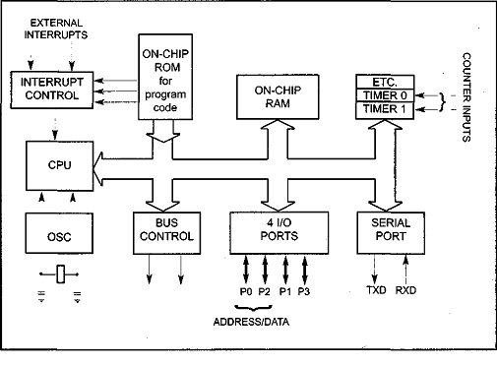

Other members of the 8051 family
There are two other members in the 8051 family of microcontrollers. They are the 8052 and the 8031.

8052 microcontroller
The 8052 is another member of the 8051 family. The 8052 has all the standard features of the 8051 as well as an extra 128 bytes of RAM and an extra timer. In other words, the 8052 has 256 bytes of RAM and 3 timers. It also has 8K bytes of on-chip program ROM instead of 4K bytes. See Table 1 -4.

Table 1.1.1: Comparison of 8051 Family Members

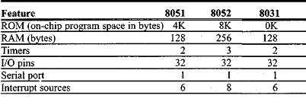

As can be seen from Table 1.1.1, the 8052 is a subset of the 8051; therefore, all programs written for the 8051 will run on the 8052, but the reverse is not true.

8031 microcontroller
Another member of the 8051 family is the 8031 chip. This chip is often referred to as a ROM-less 8051 since it has OK bytes of on-chip ROM. To use this chip you must add external ROM to it. This external ROM must contain the program that the 8031 will fetch and execute. Contrast that to the 8051 in which the on-chip ROM contains the program to be fetched and executed but is limited to only 4K bytes of code. The ROM containing the program attached to the 8031 can be as large as 64K bytes. In the process of adding external ROM to the 8031, you lose two ports. That leaves only 2 ports (of the 4 ports) for I/O operations. To solve this problem, you can add external I/O to the 8031. There are also various speed versions of the 8031 available from different companies.

Various 8051 microcontrollers
Although the 8051 is the most popular member of the 8051 family, you will not see “8051″ in the part number. This is because the 8051 is available in different memory types, such as UV-EPROM, flash, and NV-RAM, all of which have different part numbers. The UV-EPROM version of the 8051 is the 8751. The flash ROM version is marketed by many companies including Atmel Corp. and Dallas Semiconductor. The Atmel Flash 8051 is called AT89C51, while Dallas Semiconductor calls theirs DS89C4xO (DS89C420/430/440). The NV-RAM version of the 8051 made by Dallas Semiconductor is called DS5000. There is also an OTP (one-time programmable) version of the 8051 made by various manufacturers. Next we discuss briefly each of the above chips and describe applications where they are used.

8751 microcontroller
This 8751 chip has only 4K bytes of on-chip UV-EPROM. Using this chip for development requires access to a PROM burner, as well as a UV-EPROM eraser to erase the contents of UV-EPROM inside the 8751 chip before you can program it again. Because the on-chip ROM for the 8751 is UV-EPROM, it takes around 20 minutes to erase the 8751 before it can be programmed again. This has led many manufacturers to introduce flash and NV-RAM versions of the 8051, as we will discuss next. There are also various speed versions of the 8751 available from different companies.

Table 1.1.2: Versions of 8051 From Atmel (All ROM Flash)

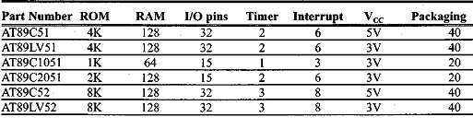

OTP version of the 8051
There are also OTP (one-time-programmable) versions of the 8051 available from different sources. Flash and NV-RAM versions are typically used for product development. When a product is designed and absolutely finalized, the OTP version of the 8051 is used for mass production since it is much cheaper in terms of price per unit.

SECTION 1.2: CHOOSING THE RIGHT MICROCONTROLLER

I/O Pins
Our project’s aim is to successfully interface a digital sensor, an analog one, an LCD to display the data taken from the two sensors, some buttons and some LED’s. All these components will communicate with the uC through its I/O pins.

The digital sensor we will use works on “One-wire” protocol , which means that data read from the environment is sent to the microcontroller serially, which means we only need 1 pin for the digital sensor.

The analog sensor will require an ADC (Analog to Digital Converter) in order to read and convert analog data into digital 8-bit data, which will then be interpreted. So the analog sonsor requires 8 pins for the parallel data sent and 3 more for its control pins (we will see more on this later), which gives us a total of 11 pins.

The 16x2 LCD we will interface also takes 11 pins (8 pins for parallel data transmission and another 3 for the control pins).

So as a matter of I/O pins the project requires at least (1 + 11 + 11) 23 pins, and another 4-5 pins for further features. The best choice regarding the I/O pins needed is the 32 pins microcontrollers.

Internal Memory
In what concerns the internal memory needed for this project a classical/minimal configuration of 4K ROM + 128bytes RAM is sufficient as the complexity of the code needed for the application is relatively low.

Voltage Supply
As most of the other components integrated in this system use around 5V to power-up, a 5V will be used also for the microcontroller.

Conclusion

After all the research and considering all the needs of this project we decided to use the AT89C51 microcontroller, manufactured by Atmel Corp.
AT89C51 Datasheet

The AT89C51 is a low-power, high-performance CMOS 8-bit microcomputer with 4K
bytes of Flash programmable and erasable read only memory (PEROM). The device
is manufactured using Atmel’s high-density nonvolatile memory technology and is
compatible with the industry-standard MCS-51 instruction set and pinout. The on-chip
Flash allows the program memory to be reprogrammed in-system or by a conventional nonvolatile memory programmer. By combining a versatile 8-bit CPU with Flash
on a monolithic chip, the Atmel AT89C51 is a powerful microcomputer which provides
a highly-flexible and cost-effective solution to many embedded control applications.

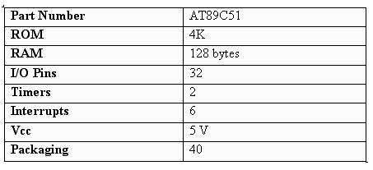
Table 1.2.0: Lists some General Features of the AT89C51

Figure 1.2.0: Features the 40 available pins of AT89C51 (32 I/O pins)
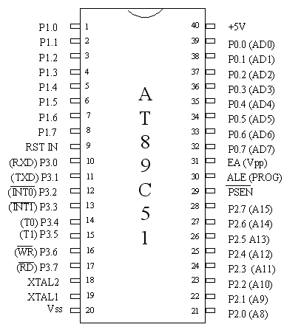

SECTION 1.3: TEMPERATURE SENSORS OVERVIEW

Some applications, such as equipment used to create life-saving medications, require temperature sensors to be responsive and accurate for critical quality control; however, some applications, like the thermometer in your car, don’t require as accurate or responsive sensors. The four most common types of temperature sensors, ranging in responsiveness and accuracy from high to low are:

- Negative Temperature Coefficient (NTC) Thermistors
- Resistance Temperature Detectors (RTDs)
- Thermocouples
- Semiconductor-Based Sensors

Temperature Sensor Types

1. Negative Temperature Coefficient (NTC) thermistor
A thermistor is a thermally sensitive resistor that exhibits a continuous, small, incremental change in resistance correlated to variations in temperature. An NTC thermistor provides higher resistance at low temperatures. As temperature increases, the resistance drops incrementally, according to its R-T table. Small changes reflect accurately due to large changes in resistance per °C. The output of an NTC thermistor is non-linear due to its exponential nature; however, it can be linearized based on its application. The effective operating range is -50 to 250 °C for glass encapsulated thermistors or 150°C for standard thermistors.

2. Resistance Temperature Detector (RTD)
A resistance temperature detector, or RTD, changes the resistance of the RTD element with temperature. An RTD consists of a film or, for greater accuracy, a wire wrapped around a ceramic or glass core. Platinum makes up the most accurate RTDs while nickel and copper make RTDs that are lower cost; however, nickel and copper are not as stable or repeatable as platinum. Platinum RTDs offer a highly accurate linear output across -200 to 600 °C but are much more expensive than copper or nickel.

3. Thermocouples
A thermocouple consists of two wires of different metals electrically bonded at two points. The varying voltage created between these two dissimilar metals reflects proportional changes in temperature. Thermocouples are nonlinear and require a conversion with a table when used for temperature control and compensation, typically accomplished using a lookup table. Accuracy is low, from 0.5 °C to 5 °C but thermocouples operate across the widest temperature range, from -200 °C to 1750 °C.

4. Semiconductor-based temperature sensors
A semiconductor-based temperature sensor is usually incorporated into integrated circuits (ICs). These sensors utilize two identical diodes with temperature-sensitive voltage vs current characteristics that are used to monitor changes in temperature. They offer a linear response but have the lowest accuracy of the basic sensor types. These temperature sensors also have the slowest responsiveness across the narrowest temperature range (-70 °C to 150 °C).

Consideration:
The right sensor type for our applications seems to be the last one (4. Semiconductor-based temperature sensors). The reasoning behind this consideration will be explained in the following section.

SECTION 1.4: CHOOSING THE TEMPERATURE SENSOR (ANALOG)

Hypothesis

First of all, we must consider the technical requirements of our application in choosing the right type and model of temperature sensor. The aim of this Data Acquisition System is to monitor and display temperature and humidity in the surrounding environment.

Precision and Accuracy
The measuring of these properties does not require very much precision and accuracy, as it is not vital for the user to know the exact temperature of his surrounding. A close approximation (0.5°C – 1°C is considered good enough). Of course it would be great if te user could measure the temperature up to 3 decimals, but this would highly increase the cost of this project, and it would lower the cost-effectiveness, considering the aim of this application.

Figure 1.3.0: Graphical representation of Precision vs Accuracy (people are often confused by these terms)
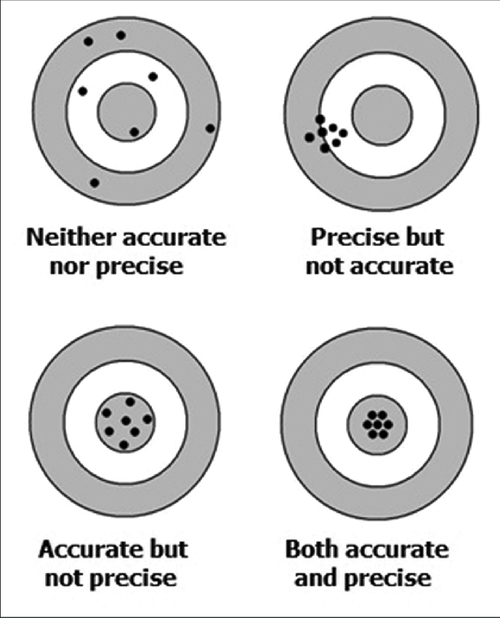

Range Rating
Another important aspect of the sensor is its range. As our application is meant to measure environmental temperature, the range of measuring does not need to be very wide – 0°C – 100°C would be more than enough. We want our application to be used in human-withstanding environments.

Voltage Supply
As we already discussed, the microcontroller we will use requires a 5V voltage supply, so it would be optimal to remain in the same parameters for the other components. So our desires temperature sensor must work at 5V voltage supply.

Interfacing
The last and maybe most important aspect in choosing the temperature sensor is its interfacing with the microcontroller and the system. For the temperature sensor we will use an analog one. Meaning that the data indicating the temperature of the environment will be sent in analog voltage format – for this matter we will need an ADC (Analog to Digital Convertor), but this will be discussed later.

Conclusion

After all the research and considering all the needs of this project we decided to use the LM35 manufactured by Texas Instruments.
LM35 Datasheet

LM35 is a temperature sensor that outputs an analog signal which is proportional to the instantaneous temperature. The output voltage can easily be interpreted to obtain a temperature reading in Celsius. The advantage of lm35 over thermistor is it does not require any external calibration. The coating also protects it from self-heating. Low cost (approximately $0.95) and greater accuracy make it popular among hobbyists, DIY circuit makers, and students. Many low-end products take advantage of low cost, greater accuracy and used LM35 in their products. Its approximately 15+ years to its first release but the sensor is still surviving and is used in any products.

LM35 Temperature sensor Features:

- Calibrated Directly in Celsius (Centigrade)
- Linear + 10-mV/°C Scale Factor
- 0.5°C Ensured Accuracy (at 25°C)
- Rated for Full −55°C to 150°C Range
- Suitable for Remote Applications
- Operates from 4 V to 30 V
- Less than 60-µA Current Drain
- Low Self-Heating, 0.08°C in Still Air
- Non-Linearity Only ±¼°C Typical
- Low-Impedance Output, 0.1 Ω for 1-mA Load

Figure 1.3.1: LM35 Pin-Out
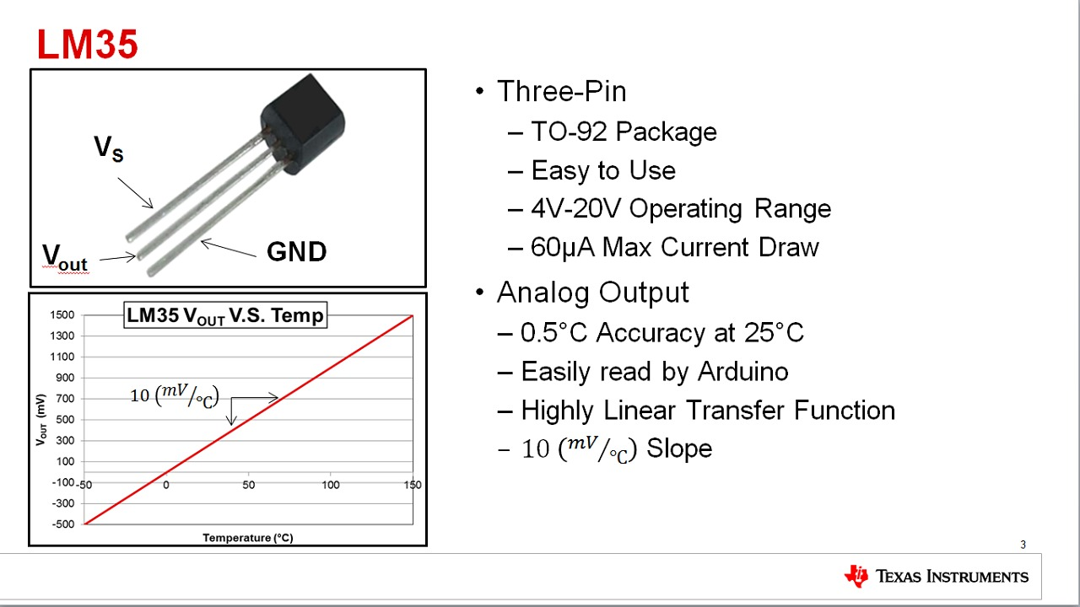

​LM35 can measure from -55 degrees centigrade to 150-degree centigrade. The accuracy level is very high if operated at optimal temperature and humidity levels. The conversion of the output voltage to centigrade is also easy and straight forward.
​The input voltage to LM35 can be from +4 volts to 30 volts. It consumes about 60 microamperes of current. Lm35 has many family members a few names are LM35C, LM35CA, LM35D, LM135, LM135A, LM235, LM335. All LM35 family members work on the same principles but temperature measuring capacity varies and also they are available in many packages (SOIC, TO-220, TO-92, TO ).

LM35 Working Principle (Understanding LM35 Linear Scale Factor)

In order to understand the working principle of LM35 temperature sensor we have to understand the linear scale factor. In the features of LM35 it is given to be+10 mills volt per degree centigrade. It means that with increase in output of 10 mills volt by the sensor Vout pin the temperature value increases by one. For example, if the sensor is outputting 100 mills volt at Vout pin the temperature in centigrade will be 10-degree centigrade. The same goes for the negative temperature reading. If the sensor is outputting -100 mills volt the temperature will be -10 degrees Celsius.

Table 1.3.0: LM35 Accuracy Level

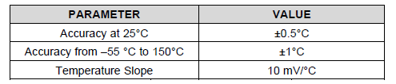

SECTION 1.5: ANALOG TO DIGITAL CONVERTER (ADC0804)

As we already mentioned, the analog data sent by yhe temperature sensor must be converted to digital values (discretized) before being sent to the microcontroller. In order to achieve this, we will use an ADC (Analog to Digital Converter). For that purpose we will use ADC0804 , an 8-bit ADC which is remarkably easy to interface (when compared to other similar ADC like ADC0808).

Figure 1.5.0: ADC0804 Pin Diagram
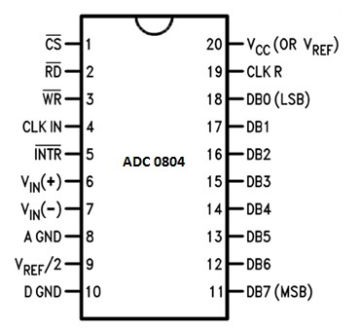

Its main features are given below:

- 8 bit resolution
- Differential analogue voltage inputs
- 0-5V input voltage range
- No zero adjustment
- Built-in clock generator
- Voltage at Vref/2 (pin9) can be externally adjusted to convert smaller input voltage spans to full 8 bit resolution.

Resolution
Resolution refers to the conversion of an analog voltage to a digital value. It indicates the number of discrete values that an ADC can produce over the range of analog values. The values are usually stored electronically in binary form, so the resolution is usually expressed in bits.

Step-Size
It is the voltage difference between one digital level and the next level that can be measured by ADC. In a 4-bit converter, an input of 1 Volt produce an output of 0001, then the step size is 1 Volt. 0 volts is always considered 0000. Distortion in the signal can be reduced by decreasing the step size to 0.5 voltsbut it lowers the maximum input reading. Ife we are using smaller step size, higher bit converter is needed to have maximum voltage.

ADC0804 is a single channel analog to digital convertor. It takes only one analog signal. It has 8 bit resolution. Other ADC can have n bit resolution and n can be 8,10,12,16 or 24 bits. If ADC has higher resolution, it gives smaller step size.If ADC has 8 bit resolution, input voltage span is 0-5V and the step size is 19.53mV (5V/255). In this situation we called Vref/2 as left open.

PIN DESCRIPTION:

Pin description of ADC0804 is given below:

CS: Chip Select
It is an active low pin and is used to activate ADC0804

RD: Read
It is an input pin and is active low. ADC stores the result in an internal register after conversion of analog data. This pin helps to get the data out of the ADC0804.
When CS=0, high to low pulse is given to RD pin, then digital output comes on the pins D0-D7

WR: Write
It is an input pin and is active low which is used to initiate the ADC to start the conversion process.
When CS=0, WR makes a low to high transition, then ADC starts the conversion process.

CLK IN: Clock IN
This is an input pin which is connected to an external clock source.

INTR: Interrupt
This is an output pin and is active low.When the conversion is over, this pin goes low.

Vin+: Analog Input
Analog input to ADC.

Vin-: Analog Input.
Analog input connected to ground.

AGND: Analog Ground
Connected to ground.

Vref/2: Reference Voltage
Used to set the reference voltage. Default reference voltage is 5V when not connected.Step size can be reduced by using this pin.

DGND: Digital Ground
Connected to ground.

D7-D0: Output Data Bits

Output bits of binary data.

CLKR: Clock Reset
To reset the clock.

Vcc: Positive Supply
Power supply of ADC.

CONVERSION STEPS:

Firstly make CS=0.
Send a low to high pulse to WR pin to start the conversion.
Keep checking the INTR pin.
INTR = 1, if conversion is not finished, poll until it is finished

INTR = 0, if conversion is finished.

If conversion is finished (INTR=0), Ensure CS=0
Then, send a high to low pulse to RD pin to read the data from the ADC.
If we connect CS of ADC to ground, then there will be no need to make or ensure it to zero.

Connection to 8051 Microcontroller:

As we know that microcontroller will provide control signals to the ADC. Its main connections are as follow:

Figure 1.5.1: Functioning of the ADC0804
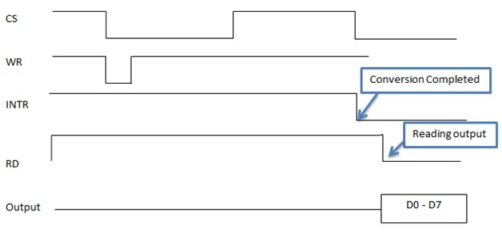

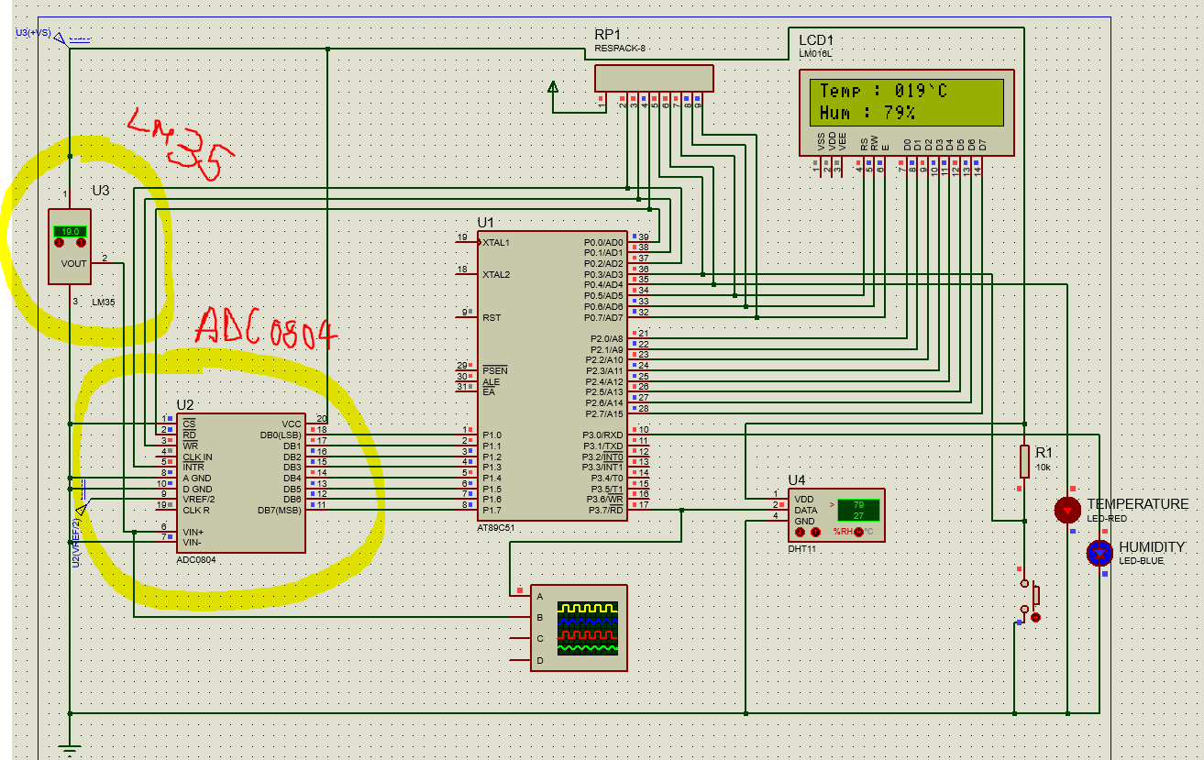
Figure 1.5.2: Proteus schematic of the project. Analog sensor and ADC are highlighted

Figure 1.5.3: Embedded C code to interface the ADC
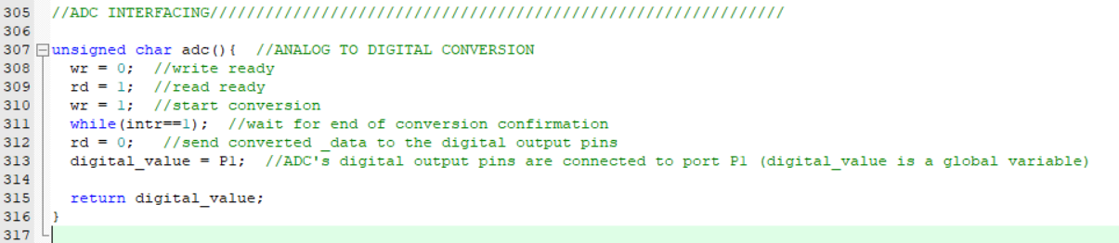

SECTION 1.6: HUMIDITY SENSORS (DIGITAL)

For the humidity sensor we will use a digital sensor that works on the Single Wire (One-Wire) communication protocol. Unlike the temperature sensor (which is analog), data is sent in digital format. The chosen sensor is DHT11 manufactured by Mouser. We will discuss its functioning and interfacing with the 8051 in this section.

The DHT11 is a humidity & temperature sensor, but we will only use the humidity information, as temperature is already handled by the analog LM35 sensor.

DHT11 Datasheet

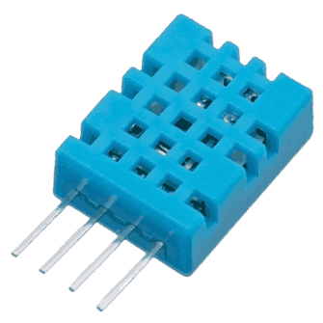

General features and Interfacing
The DHT11 is a basic, low cost digital temperature and humidity sensor.

DHT11 is a single wire digital humidity and temperature sensor, which provides humidity and temperature values serially with one-wire protocol.
DHT11 sensor provides relative humidity value in percentage (20 to 90% RH) and temperature values in degree Celsius (0 to 50 °C).
DHT11 sensor uses resistive humidity measurement component, and NTC temperature measurement component.

SECTION 1.2: REFERENCES & RESOURCES

https://what-when-how.com/8051-microcontroller/overview-of-the-8051-family/

https://www.canva.com/

https://www.engineersgarage.com/electronic-projects/lm35-description-and-working-principal/

https://www.mouser.com/datasheet/2/758/DHT11-Technical-Data-Sheet-Translated-Version-1143054.pdf

